Name: Trina Roy

Reg. no: 1703690

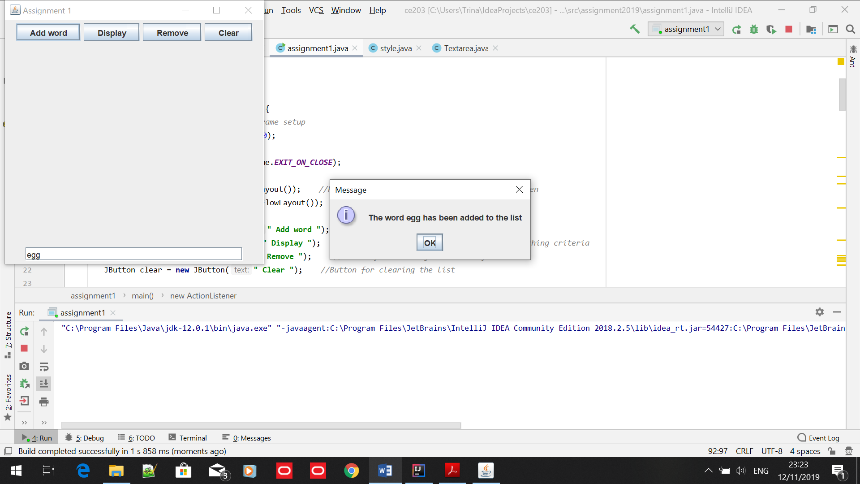

1. Adding the word “egg” to the list

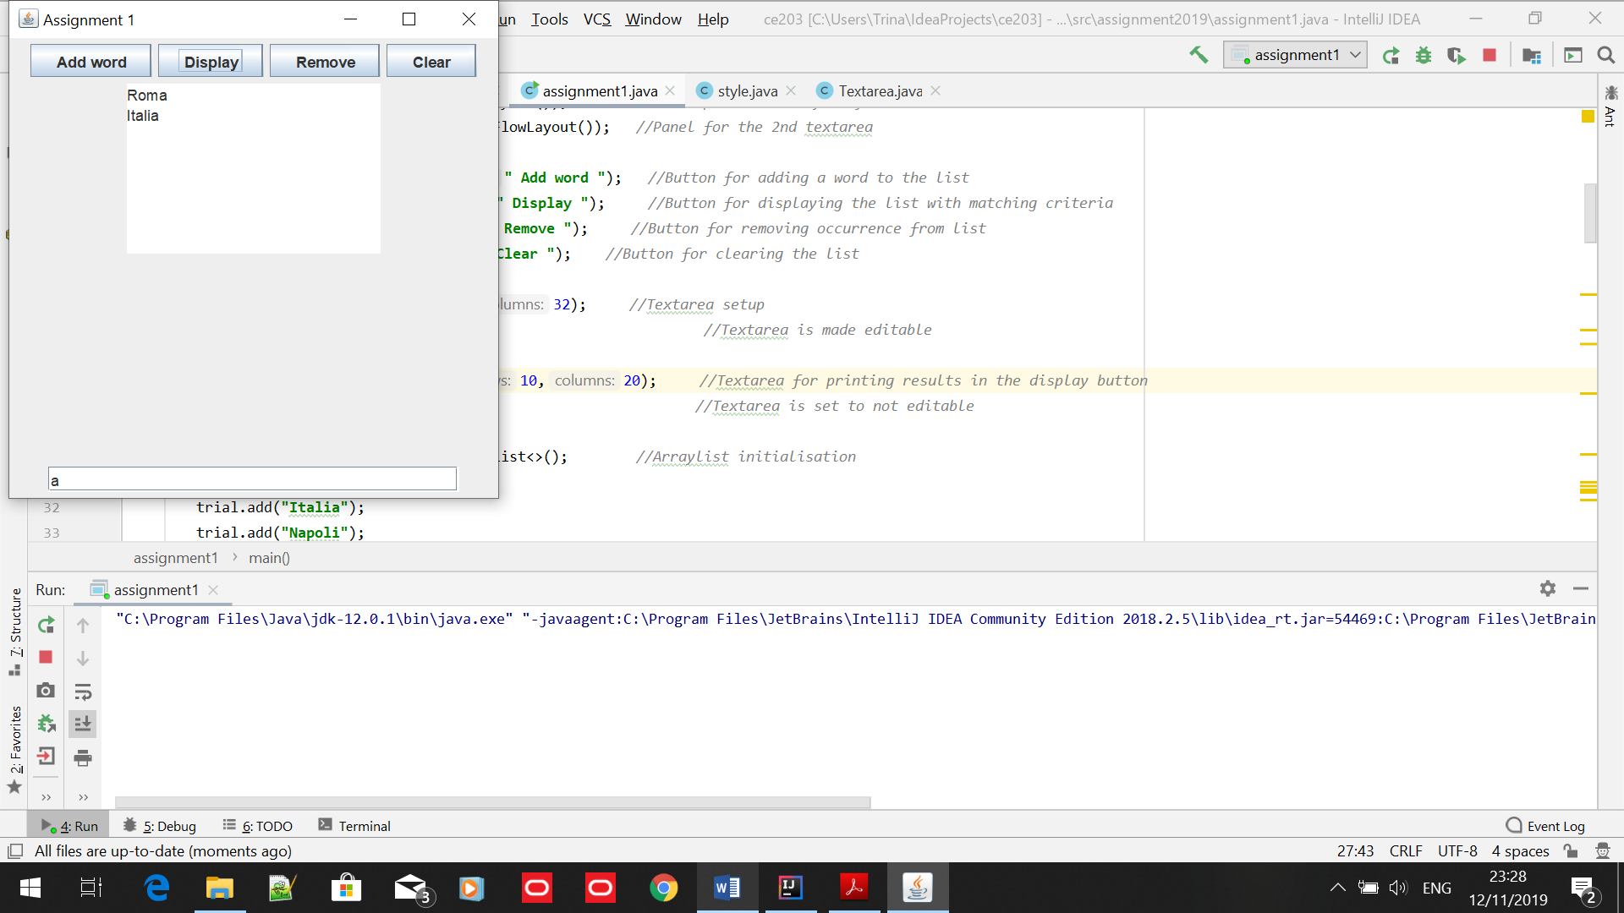

1. Displaying the output if a letter was entered

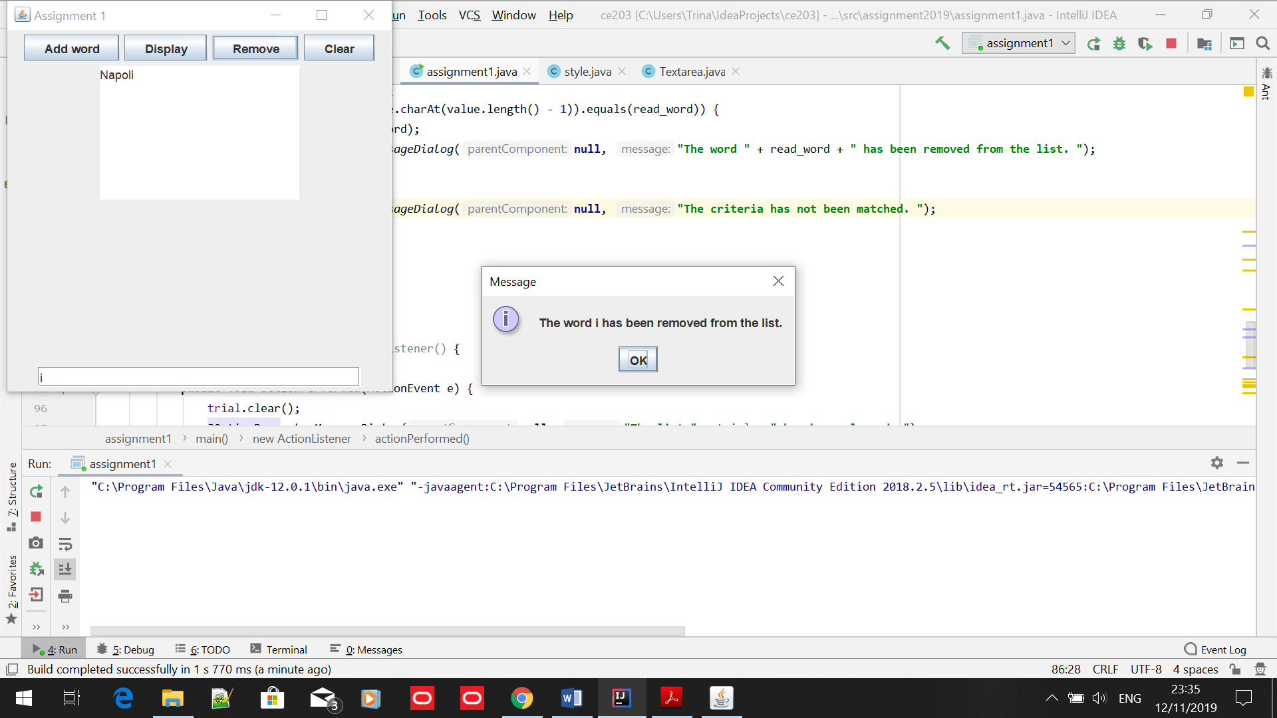

1. Removing words from the list

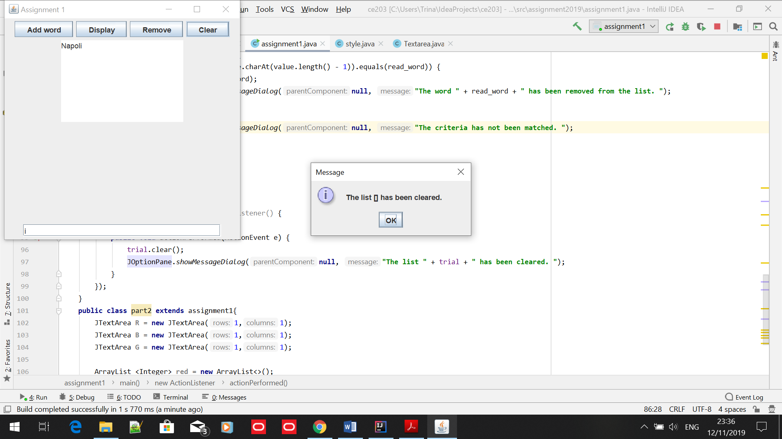

1. Clearing the list

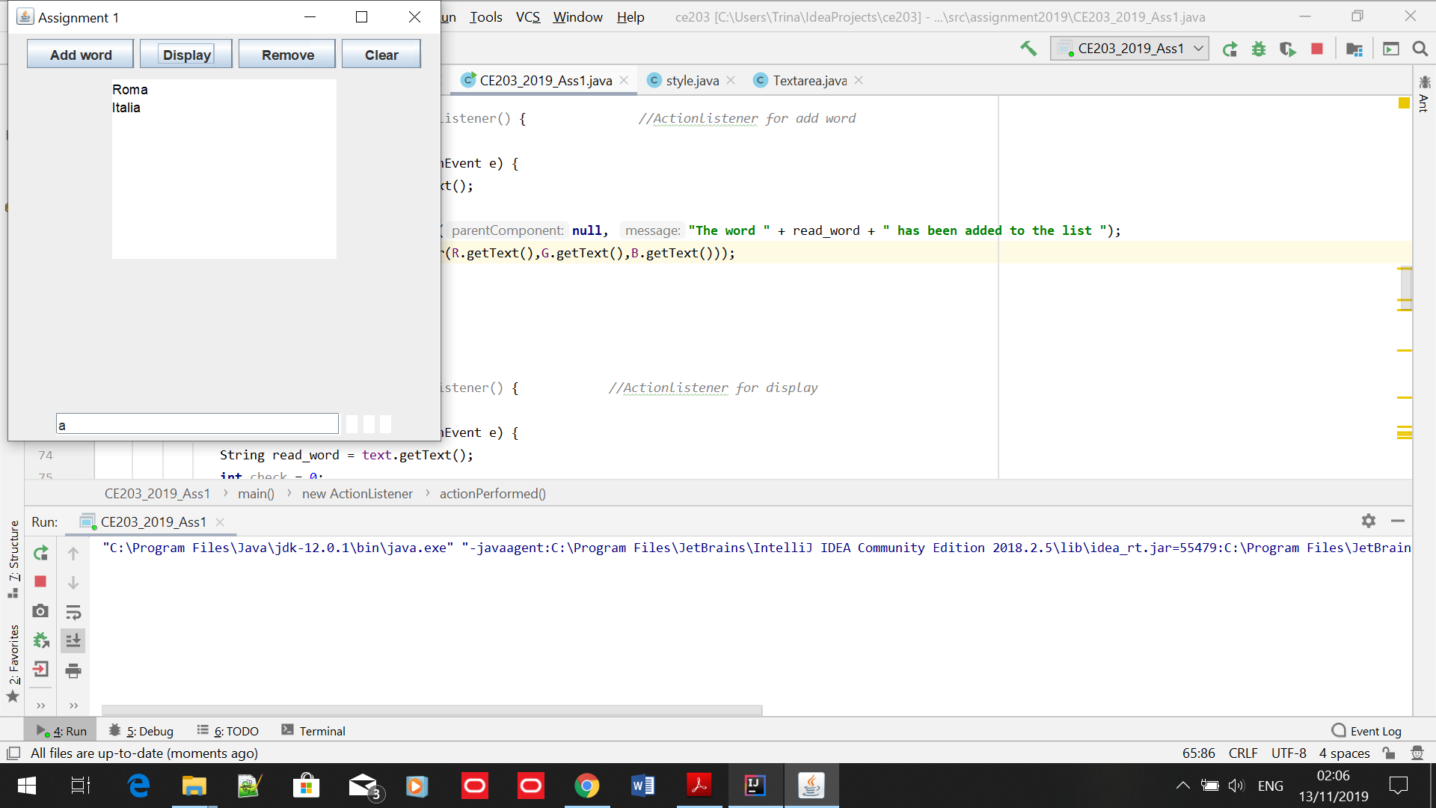

1. The colour of the text as normal

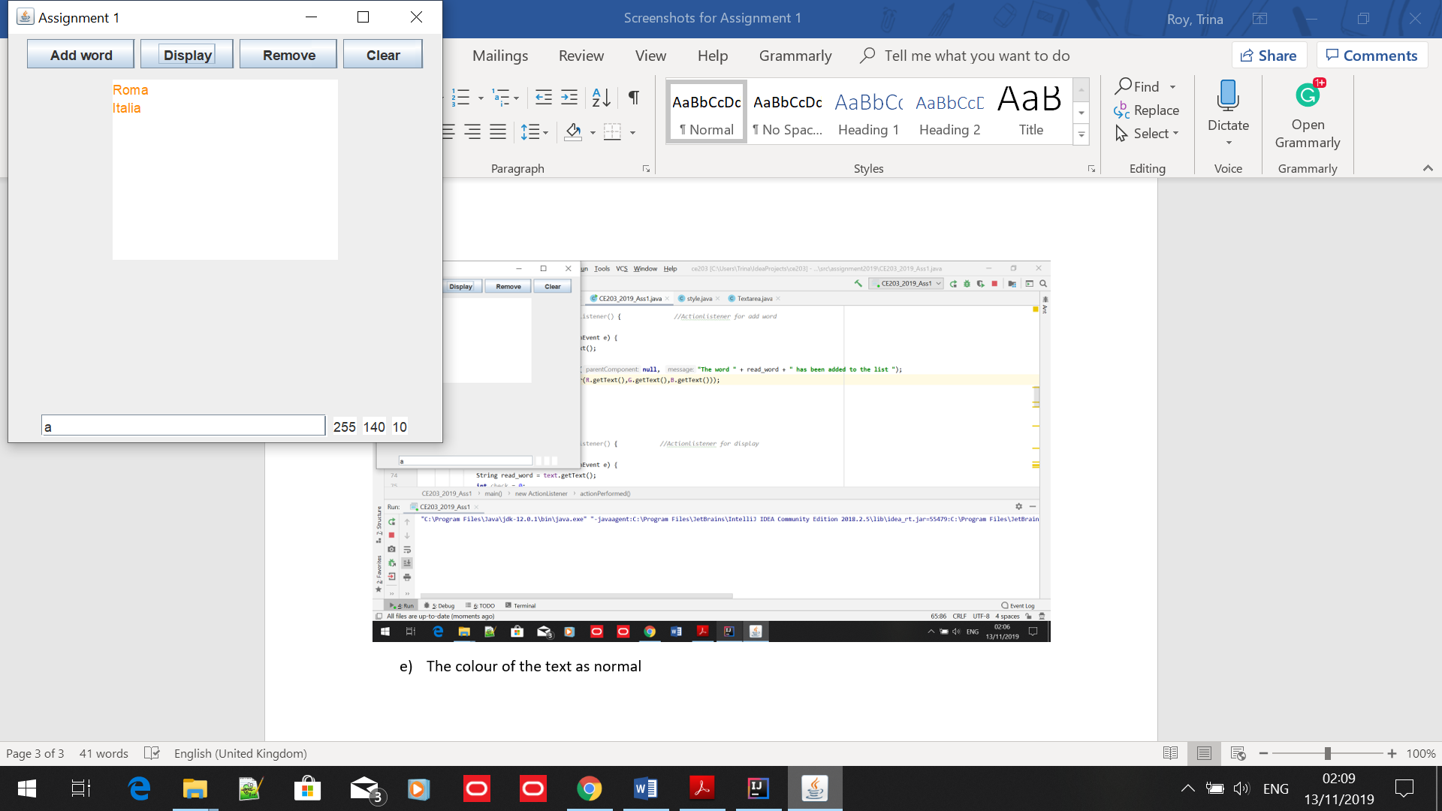

1. This is the text after I have changed the colour.